
SFOUK Event Pack 2018

Tips to run an ENT event
for SFOUK representatives



Contents Page

Introduction 3

The event 4

Elements for a successful event 5

Step by step guide 10

Introduction

ENT is an exciting, dynamic and rewarding career. As an SFOUK representative you are in a key position to work with students and junior trainees in your area, to promote ENT and encourage them to consider the specialty as a career.

The aims of this pack are:

- To give ideas of events that can be run in your area
- To give logistical advice about running an event
- To use as a step by step guide when planning your event

This guide is aimed to give you a few key tips to enhance your ENT event for yourselves and for your audience. It is laid out to enable you to choose the way you use it; you may prefer to start at the beginning and read through or pick out relevant parts.

The event

First of all come up with an event outline that will attract your desired audience, be that junior or senior medical students, or FY doctors. Are you aiming to promote ENT as a career, or wanting to run practical or revision sessions?

Plan how you will deliver your talks, either lecture based or workshop/skills sessions, or both. Below are ideas of events you could hold.

Event outline

Draw up a brief outline of how you envisage the event at the start of the process. This will help determining an appropriate venue, secure speakers and promote the event to your audience. Think about the overall aim of the event, benefits of attendance, an indication of the date, timings and location (even if these are still to be finalized). Plan if you will run the event independently or with the local student surgical society or with other surgical specialties. Combining your event may mean you get a larger audience!

Ideas for events

A career in ENT
You could deliver a lecture outlining a career in ENT, average day in ENT, subspecialties and career path, as well as promoting SFOUK. The benefits of this are that a lecture can reach a wider audience and can be aimed from junior medical students to FY doctors.

SFOUK have created a set of lecture slides on “a career in ENT” that can be used at such an event.

ENT practical skills
ENT practical skills sessions are an excellent way to engage students and junior doctors and a good way of enticing budding surgeons to an event! ENT is very much a skill-based specialty and these can easily be taught in small group format. Ideas could include epistaxis management, ear examination and audiograms, tracheostomy, quinsy drainage and nasendoscopy.

Practical skill sessions can also be run as a mock OSCE session for medical students coming up to exams. We will go through how best to plan these sessions in the equipment section.

Elements for a successful event

Trainers

First off, before you run an event you need people to help, especially if you are running practical sessions. You don’t want to be in a position where you have lots of interest but no one to help!

Medical students are a great help in promoting the event and can aid with setting up and running the event. Liaise with your local medical school surgical society for this or other SFOUK student reps.

Speak with colleagues and find a date when you are all free. Setting up a ‘Doodle poll‘ can help with this. If you are aiming an event at medical students, then FY doctors upwards can run sessions if they have done an ENT job, otherwise contact your local ENT department; they will likely have some friendly ENT themed core trainees and registrars who will be happy to lend a hand. Make sure you offer trainer certificates for evidence to use in their portfolios. Plan between trainers what roles people will play and what you would all like to do.

Date and time

Think about exam times and holidays or other events that could make your event less popular. Best not to run an event in the middle of exams! Speak with the medical school student centre to check for other events that are running or ask the student surgical society.

Do you plan to hold your event in the daytime, evening or weekend? Evening events work well as people don’t have to give up a weekend. In addition medical schools will be more likely to lend you a lecture theatre/room, as they will have no sessions running concurrently. If you are running an evening event, think about which evening in the week – historically students have sports socials on Wednesday and Fridays may generally be unpopular.

Think about how long you will need for the event. A careers talk will likely take around 30 minutes and you will need at least 20-30 minutes for each skills session, with enough time in-between for attendees to rotate around stations.

Venue

If you are running a lecture, you will need the facilities to show slides and enough room. For small group skills sessions, you will need enough space for tables and for groups to run simultaneously.

Student surgical societies run events regularly and they may even liaise with the medical school on your behalf to secure lecture theatres or rooms. You could also speak with your hospital’s postgraduate centre.

It has been known that some local private hospitals have given space for free for student events!

Your venue may depend on your audience number. Discuss options with your venue about using larger rooms if you need to closer to the event.

Audience

Now you have trainers, a date and a venue, think about your target audience and how you will promote the event to this group.
It could be open to all medical students or just 4th/5th years. Similarly, you may want to run an event aimed at Foundation Doctors.
You could even tie up with other surgical specialties and aim at all budding surgeons and each hold a short talk.

You may need to have a maximum audience number depending on the number of trainers you have. If you have 5 trainers and want to do skills sessions, you may want to keep the maximum number to 25, otherwise >5 attendees per station may be too big.

If you are promoting to medical students, the local medical school surgical society will have a member’s mailing list who are most likely to be the group to target. You could also ask student coordinators if your event could be advertised in the student newsletter.

For foundation doctors, ask the foundation doctor coordinator if they could send an email out to promote the event to FYs or put posters up in the Doctors Mess.

Either way, it’s a good idea at this point to ask potential attendees to email their interest, so you have an idea of numbers for your event.

Equipment and promotional materials

If you are running skills sessions you will need equipment. Speak with local ENT departments (consultants or registrars) who may lend you models or stock, especially if their department runs a BEST (Basic ENT Skills Teaching) course to their own trainees.
Also speak with the medical school skills centre or hospital postgraduate training centre. They often have great models (e.g. airway models are useful to practice scoping).

Discuss with your local ENT consultants if they have contacts for local medical reps. For example, Storz often have portable stacks, which they can bring to sessions for trainees to use on models.
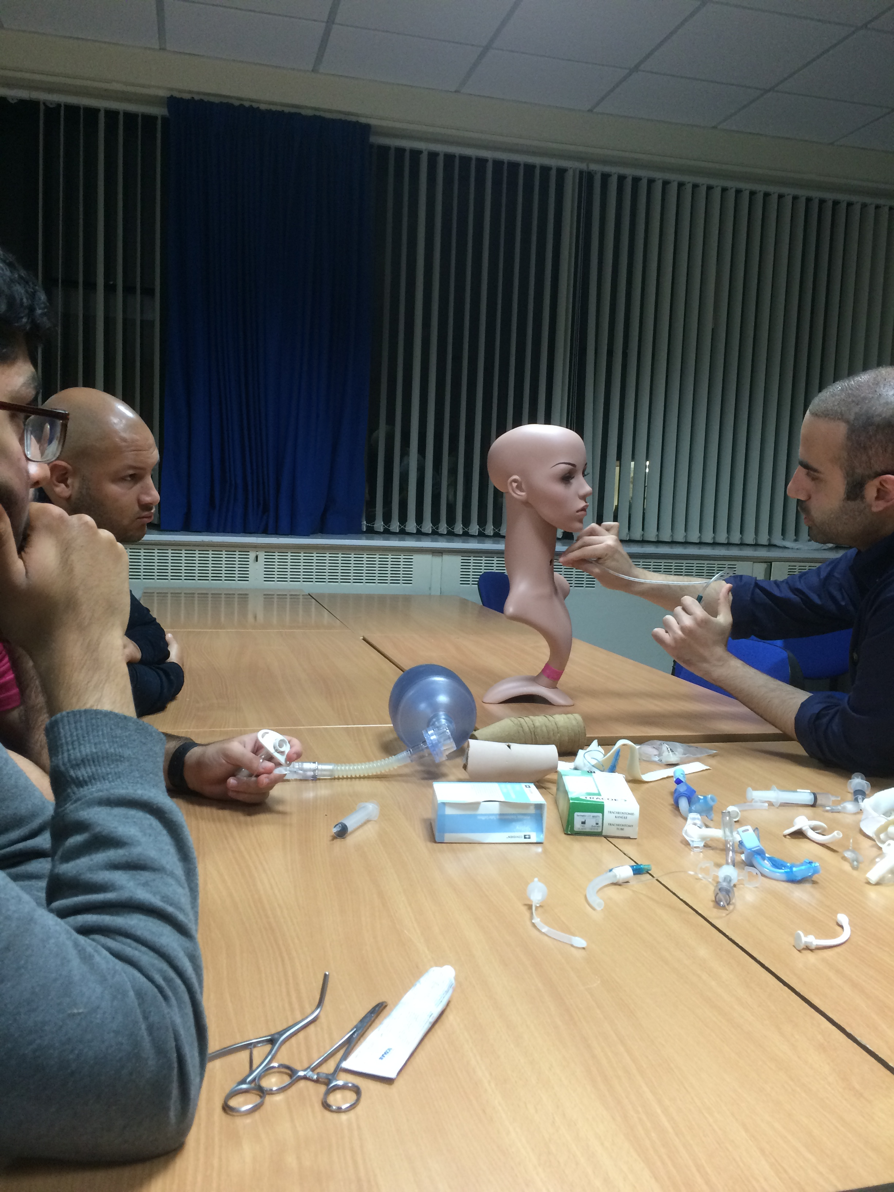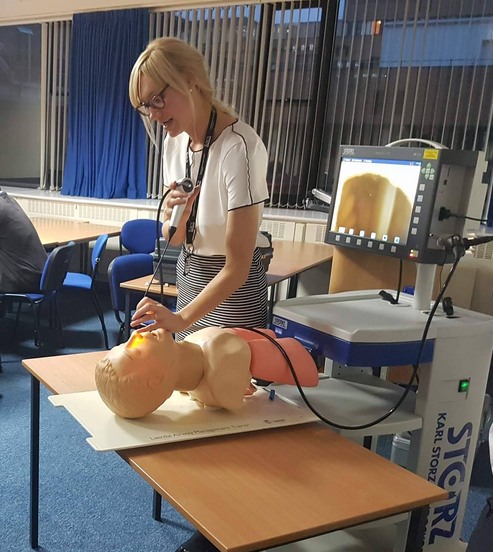

Promotional materials are available for free from the ENTUK office – career leaflets, pens/paper/post-its/lanyards etc. They will post these to you free of charge. There is also a SFO “pop-up” promotional stand that can be requested (fully refundable deposit needed), see pictures below. Contact the office at RCS: support@entuk.org or Telephone: 0207 405 8371. You can also message the SFOUK committee on our Facebook/Twitter/Instagram pages to ask for help with this.
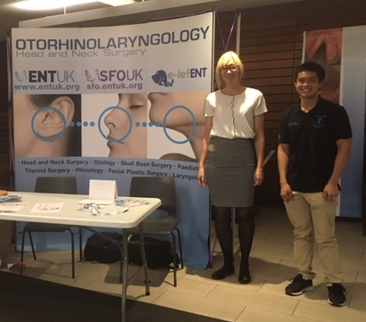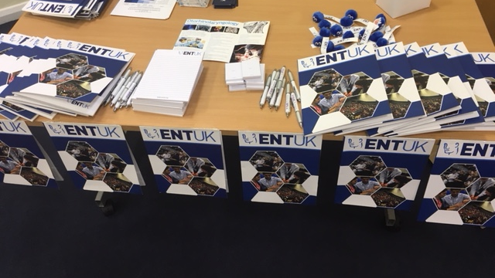

Funding
Sometimes you CAN get a free lunch! Some organizations will help fund your event to cover for venue hire and refreshments/food.

Contact the Royal College of Surgeons (RCS) or Association of Surgeons in Training (ASIT) and ask if they would kindly consider funding your event. Outline the plan for your event, how much funding would be useful and what you would use it for.

Useful contacts for funding:
RCS careers support manager: careers@rcseng.ac.uk
RCS events manager: RCSEvents@rcseng.ac.uk
ASiT: info@ASIT.org

The medical school student centre and surgical societies often have vouchers or good contacts for food discounts when ordering en-mass.

In addition, if you are planning to hold a larger event, perhaps with other surgical specialties, you could contact organizations such as the Medical Defense Union, Medical Protection Society or Wesleyan Medical Sickness to see if they would sponsor your event.

On the day of the event
Ensure you have helpers who can get there before the start of the event to set up skills stations, a stall if you have one and the promotional materials. Check your slides and projector work. Ensure all trainers know their role and time frames of the event. If you are having catering, may sure you have enough paper plates/cups etc.

Make sure someone is keeping time of the sessions to make sure you don’t run over!

After the event
It goes without saying to make sure you tidy up after yourselves and give equipment back to the relevant departments.

Send out certificates to the trainers and thank trainers/sponsors who helped.

Feedback
Last but not least, after your event, share your success and feedback by letting SFO know! We can put pictures up on our social media pages to promote and recognize the hard work you have done!

Good luck!

SFOUK Committee

Step by step guide to planning your event

Step | Task | Tick when completed
1 | Plan what kind of event you want to run and your target audience
2 | Contact potential trainers and helpers for the event
3 | Finalize a date and time
4 | Get a venue and plan around your space
5 | Promote the event to the target audience. Ask attendees to email to confirm numbers
6 | Secure equipment and promo materials
7 | Contact organizations for funding
8 | Order food/refreshments and think about what time you will have these
9 | Print off feedback forms before the event
10 | Organize certificates for your trainers

